

Assiut University
Faculty of Medicine
Dept. of ENT
Phoniatrics unit

CURRICULUM VITAE

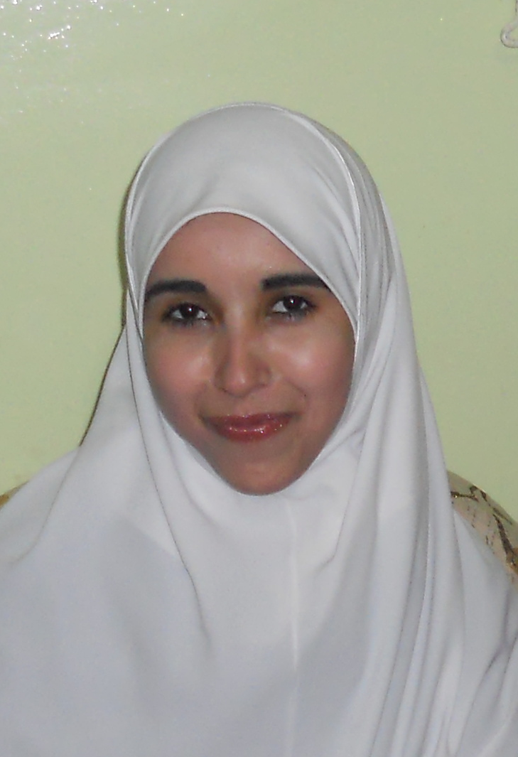

Amira Hafez Abd Elaal
Assistant lecturer of ENT,
Phoniatrics unit
Assiut University Hospital,
Assiut, Egypt
Tel: Office (+2088)2414165
E-Mail:amirahafez@aun.edu.eg


Assiut University Hospital
Amira Hafez Abd Elaal
Personal data | First name : Amira  Middle names :Hafez  Last name (Family or Surname): Abd Elaal  Tel: Hospital : +2 088 2414165  Email : amirahafez@aun.edu.eg  Date of birth :1st June,1986.  Marital status : married.  Nationality : Egyptian.  Address : Egypt, Assiut university hospital, department of ENT, Phoniatrics unit  Current hospital: Department of ENT, Phoniatrics unit, Assiut University Hospital, Assiut, Egypt.  Non-medical interests: reading novels.  Languages : Arabic and English.
Current position | Assistant lecturer of ENT,Phoniatrics unit, Assiut University Hospital, Assiut, Egypt (1/3/2014 till now).
Positions held | House officer: Assiut University Hospital (1/3/2010-28/2/2011).  Resident (Phoniatrics): Assiut University Hospital (1/3/2009-28/2/2012).
Professional licensure | Egyptian ministry of health full registration no.: 195355-2009/3/2

